[Thực hành] Spring Boot JSON Web Token (JWT)

Mục tiêu:
Luyện tập sử dụng Spring Boot + Spring Security + JSON Web Token (JWT)

Mô tả:
Trong bài này chúng ta sẽ làm ví dụ Spring Security cho những URL được dùng để gọi API (Restful Web Service) sử dụng Spring Boot.

Hướng dẫn:
Bước 1:
Tạo dự án Spring Boot:
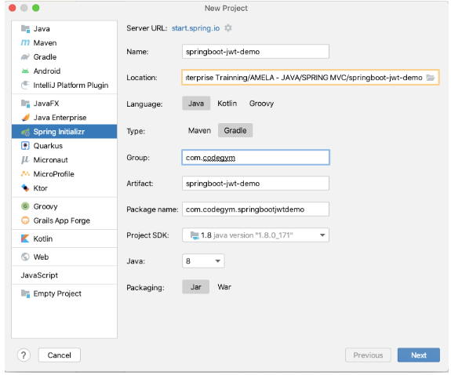
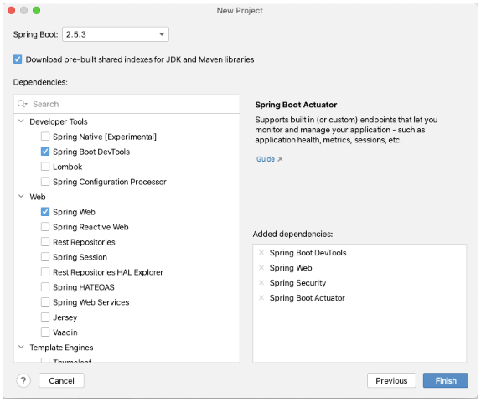
Cấu trúc dự án như sau:
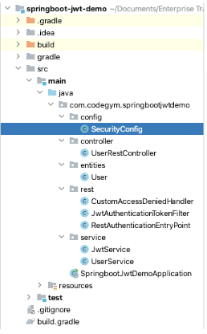
Chúng ta sử dụng thêm thư viện nimbus-jose-jwt để tạo token (decode/encode token, chữ ký số) và commons-lang3 để xử lý Strings
dependencies {
implementation 'org.springframework.boot:spring-boot-starter-actuator'
implementation 'org.springframework.boot:spring-boot-starter-security'
implementation 'org.springframework.boot:spring-boot-starter-web'
developmentOnly 'org.springframework.boot:spring-boot-devtools'
testImplementation 'org.springframework.boot:spring-boot-starter-test'
testImplementation 'org.springframework.security:spring-security-test'
implementation group: 'com.nimbusds', name: 'nimbus-jose-jwt', version: '4.20'
implementation group: 'org.apache.commons', name: 'commons-lang3', version: '3.7'
}
Bước 2:
Tạo File entity:
package com.codegym.springbootjwtdemo.entities;
import java.util.ArrayList;
import java.util.List;
import org.springframework.security.core.GrantedAuthority;
import org.springframework.security.core.authority.SimpleGrantedAuthority;
import com.fasterxml.jackson.annotation.JsonIgnoreProperties;
import com.fasterxml.jackson.annotation.JsonInclude;
@JsonInclude(JsonInclude.Include.NON_NULL)
@JsonIgnoreProperties(value = { "roles", "authorities" })
public class User {
private int id;
private String username;
private String password;
private String[] roles;
public User() {
}
public User(int id, String username, String password) {
this.id = id;
this.username = username;
this.password = password;
}
// getter - setter
public int getId() {
return id;
}
public void setId(int id) {
this.id = id;
}
public String getUsername() {
return username;
}
public void setUsername(String username) {
this.username = username;
}
public String getPassword() {
return password;
}
public void setPassword(String password) {
this.password = password;
}
public String[] getRoles() {
return roles;
}
public void setRoles(String[] roles) {
this.roles = roles;
}
public List<GrantedAuthority> getAuthorities() {
List<GrantedAuthority> authorities = new ArrayList<GrantedAuthority>();
for (String role : roles) {
authorities.add(new SimpleGrantedAuthority(role));
}
return authorities;
}
}
Bước 3:
Tạo File Controller:
package com.codegym.springbootjwtdemo.controller;
import java.util.List;
import javax.servlet.http.HttpServletRequest;
import org.springframework.beans.factory.annotation.Autowired;
import org.springframework.http.HttpStatus;
import org.springframework.http.ResponseEntity;
import org.springframework.security.authentication.AuthenticationManager;
import org.springframework.web.bind.annotation.PathVariable;
import org.springframework.web.bind.annotation.RequestBody;
import org.springframework.web.bind.annotation.RequestMapping;
import org.springframework.web.bind.annotation.RequestMethod;
import org.springframework.web.bind.annotation.RestController;
import com.codegym.springbootjwtdemo.entities.User;
import com.codegym.springbootjwtdemo.service.JwtService;
import com.codegym.springbootjwtdemo.service.UserService;
@RestController
@RequestMapping("/rest")
public class UserRestController {
@Autowired
private JwtService jwtService;
@Autowired
private UserService userService;
/* ---------------- GET ALL USER ------------------------ */
@RequestMapping(value = "/users", method = RequestMethod.GET)
public ResponseEntity<List<User>> getAllUser() {
return new ResponseEntity<List<User>>(userService.findAll(), HttpStatus.OK);
}
/* ---------------- GET USER BY ID ------------------------ */
@RequestMapping(value = "/users/{id}", method = RequestMethod.GET)
public ResponseEntity<Object> getUserById(@PathVariable int id) {
User user = userService.findById(id);
if (user != null) {
return new ResponseEntity<Object>(user, HttpStatus.OK);
}
return new ResponseEntity<Object>("Not Found User", HttpStatus.NO_CONTENT);
}
/* ---------------- CREATE NEW USER ------------------------ */
@RequestMapping(value = "/users", method = RequestMethod.POST)
public ResponseEntity<String> createUser(@RequestBody User user) {
if (userService.add(user)) {
return new ResponseEntity<String>("Created!", HttpStatus.CREATED);
} else {
return new ResponseEntity<String>("User Existed!", HttpStatus.BAD_REQUEST);
}
}
/* ---------------- DELETE USER ------------------------ */
@RequestMapping(value = "/users/{id}", method = RequestMethod.DELETE)
public ResponseEntity<String> deleteUserById(@PathVariable int id) {
userService.delete(id);
return new ResponseEntity<String>("Deleted!", HttpStatus.OK);
}
@RequestMapping(value = "/login", method = RequestMethod.POST)
public ResponseEntity<String> login(HttpServletRequest request, @RequestBody User user) {
String result = "";
HttpStatus httpStatus = null;
try {
if (userService.checkLogin(user)) {
result = jwtService.generateTokenLogin(user.getUsername());
httpStatus = HttpStatus.OK;
} else {
result = "Wrong userId and password";
httpStatus = HttpStatus.BAD_REQUEST;
}
} catch (Exception ex) {
result = "Server Error";
httpStatus = HttpStatus.INTERNAL_SERVER_ERROR;
}
return new ResponseEntity<String>(result, httpStatus);
}
}
Bước 4:
Tạo File Service:
package com.codegym.springbootjwtdemo.service;
import java.util.ArrayList;
import java.util.List;
import org.apache.commons.lang3.StringUtils;
import org.springframework.stereotype.Service;
import com.codegym.springbootjwtdemo.entities.User;
@Service
public class UserService {
public static List<User> listUser = new ArrayList<User>();
static {
User userKai = new User(1, "kai", "123456");
userKai.setRoles(new String[] { "ROLE_ADMIN" });
User userSena = new User(2, "sena", "123456");
userSena.setRoles(new String[] { "ROLE_USER" });
listUser.add(userKai);
listUser.add(userSena);
}
public List<User> findAll() {
return listUser;
}
public User findById(int id) {
for (User user : listUser) {
if (user.getId() == id) {
return user;
}
}
return null;
}
public boolean add(User user) {
for (User userExist : listUser) {
if (user.getId() == userExist.getId() || StringUtils.equals(user.getUsername(), userExist.getUsername())) {
return false;
}
}
listUser.add(user);
return true;
}
public void delete(int id) {
listUser.removeIf(user -> user.getId() == id);
}
public User loadUserByUsername(String username) {
for (User user : listUser) {
if (user.getUsername().equals(username)) {
return user;
}
}
return null;
}
public boolean checkLogin(User user) {
for (User userExist : listUser) {
if (StringUtils.equals(user.getUsername(), userExist.getUsername())
&& StringUtils.equals(user.getPassword(), userExist.getPassword())) {
return true;
}
}
return false;
}
}
Chúng ta khởi tạo listUser và thực hiện truy vấn, login thêm/sửa/xóa user trên list này.
Ban đầu ta sẽ khởi tạo 2 tài khoản là kai/123456 với role ADMIN và sena/123456 với role là USER để đăng nhập và truy vấn.
package com.codegym.springbootjwtdemo.service;
import java.util.Date;
import org.springframework.stereotype.Service;
import com.nimbusds.jose.JWSAlgorithm;
import com.nimbusds.jose.JWSHeader;
import com.nimbusds.jose.JWSSigner;
import com.nimbusds.jose.JWSVerifier;
import com.nimbusds.jose.crypto.MACSigner;
import com.nimbusds.jose.crypto.MACVerifier;
import com.nimbusds.jwt.JWTClaimsSet;
import com.nimbusds.jwt.SignedJWT;
@Service
public class JwtService {
public static final String USERNAME = "username";
public static final String SECRET_KEY = "11111111111111111111111111111111";
public static final int EXPIRE_TIME = 86400000;
// OK
public String generateTokenLogin(String username) {
String token = null;
try {
// Create HMAC signer
JWSSigner signer = new MACSigner(generateShareSecret());
JWTClaimsSet.Builder builder = new JWTClaimsSet.Builder();
builder.claim(USERNAME, username);
builder.expirationTime(generateExpirationDate());
JWTClaimsSet claimsSet = builder.build();
SignedJWT signedJWT = new SignedJWT(new JWSHeader(JWSAlgorithm.HS256), claimsSet);
// Apply the HMAC protection
signedJWT.sign(signer);
// Serialize to compact form, produces something like
// eyJhbGciOiJIUzI1NiJ9.SGVsbG8sIHdvcmxkIQ.onO9Ihudz3WkiauDO2Uhyuz0Y18UASXlSc1eS0NkWyA
token = signedJWT.serialize();
} catch (Exception e) {
e.printStackTrace();
}
return token;
}
// OK
private JWTClaimsSet getClaimsFromToken(String token) {
JWTClaimsSet claims = null;
try {
SignedJWT signedJWT = SignedJWT.parse(token);
JWSVerifier verifier = new MACVerifier(generateShareSecret());
if (signedJWT.verify(verifier)) {
claims = signedJWT.getJWTClaimsSet();
}
} catch (Exception e) {
e.printStackTrace();
}
return claims;
}
// OK
private Date generateExpirationDate() {
return new Date(System.currentTimeMillis() + EXPIRE_TIME);
}
// OK
private Date getExpirationDateFromToken(String token) {
Date expiration = null;
JWTClaimsSet claims = getClaimsFromToken(token);
expiration = claims.getExpirationTime();
return expiration;
}
// OK
public String getUsernameFromToken(String token) {
String username = null;
try {
JWTClaimsSet claims = getClaimsFromToken(token);
username = claims.getStringClaim(USERNAME);
} catch (Exception e) {
e.printStackTrace();
}
return username;
}
// OK
private byte[] generateShareSecret() {
// Generate 256-bit (32-byte) shared secret
byte[] sharedSecret = new byte[32];
sharedSecret = SECRET_KEY.getBytes();
return sharedSecret;
}
// OK
private Boolean isTokenExpired(String token) {
Date expiration = getExpirationDateFromToken(token);
return expiration.before(new Date());
}
// OK
public Boolean validateTokenLogin(String token) {
if (token == null || token.trim().length() == 0) {
return false;
}
String username = getUsernameFromToken(token);
if (username == null || username.isEmpty()) {
return false;
}
if (isTokenExpired(token)) {
return false;
}
return true;
}
}
Class JwtService.java dùng để tạo và validate token. (tạo token với thông tin username, thời gian hết hạn; kiểm tra thời gian hết han, chữ ký có hợp lệ không…)
Bước 5:
Tạo File cấu hình security:
package com.codegym.springbootjwtdemo.config;
import org.springframework.context.annotation.Bean;
import org.springframework.context.annotation.Configuration;
import org.springframework.http.HttpMethod;
import org.springframework.security.authentication.AuthenticationManager;
import org.springframework.security.config.annotation.web.builders.HttpSecurity;
import org.springframework.security.config.annotation.web.configuration.EnableWebSecurity;
import org.springframework.security.config.annotation.web.configuration.WebSecurityConfigurerAdapter;
import org.springframework.security.config.http.SessionCreationPolicy;
import org.springframework.security.web.authentication.UsernamePasswordAuthenticationFilter;
import com.codegym.springbootjwtdemo.rest.CustomAccessDeniedHandler;
import com.codegym.springbootjwtdemo.rest.JwtAuthenticationTokenFilter;
import com.codegym.springbootjwtdemo.rest.RestAuthenticationEntryPoint;
@Configuration
@EnableWebSecurity
public class SecurityConfig extends WebSecurityConfigurerAdapter {
@Bean
public JwtAuthenticationTokenFilter jwtAuthenticationTokenFilter() throws Exception {
JwtAuthenticationTokenFilter jwtAuthenticationTokenFilter = new JwtAuthenticationTokenFilter();
jwtAuthenticationTokenFilter.setAuthenticationManager(authenticationManager());
return jwtAuthenticationTokenFilter;
}
@Bean
public RestAuthenticationEntryPoint restServicesEntryPoint() {
return new RestAuthenticationEntryPoint();
}
@Bean
public CustomAccessDeniedHandler customAccessDeniedHandler() {
return new CustomAccessDeniedHandler();
}
@Bean
@Override
protected AuthenticationManager authenticationManager() throws Exception {
return super.authenticationManager();
}
protected void configure(HttpSecurity http) throws Exception {
// Disable crsf cho đường dẫn /rest/**
http.csrf().ignoringAntMatchers("/rest/**");
http.authorizeRequests().antMatchers("/rest/login**").permitAll();
http.antMatcher("/rest/**").httpBasic().authenticationEntryPoint(restServicesEntryPoint()).and()
.sessionManagement().sessionCreationPolicy(SessionCreationPolicy.STATELESS).and().authorizeRequests()
.antMatchers(HttpMethod.GET, "/rest/**").access("hasRole('ROLE_ADMIN') or hasRole('ROLE_USER')")
.antMatchers(HttpMethod.POST, "/rest/**").access("hasRole('ROLE_ADMIN')")
.antMatchers(HttpMethod.DELETE, "/rest/**").access("hasRole('ROLE_ADMIN')").and()
.addFilterBefore(jwtAuthenticationTokenFilter(), UsernamePasswordAuthenticationFilter.class)
.exceptionHandling().accessDeniedHandler(customAccessDeniedHandler());
}
}
- Các url /rest/** với method GET (API lấy thông tin user) cho phép cả role ADMIN và USER truy cập, với các method “DELETE” và “POST” (xóa và tạo mới user) thì chỉ cho phép role ADMIN truy cập.
- Bean restServicesEntryPoint sẽ xử lý những request chưa được xác thực.
- Bean jwtAuthenticationTokenFilter sẽ thực hiện việc xác thực người dùng
- Trường hợp người dùng gửi request mà không có quyền sẽ do bean customAccessDeniedHandler xử lý (Ví dụ role USER nhưng gửi request xóa user)
Các class filter, handler security:
Class: CustomAccessDeniedHandler
package com.codegym.springbootjwtdemo.rest;
import java.io.IOException;
import javax.servlet.ServletException;
import javax.servlet.http.HttpServletRequest;
import javax.servlet.http.HttpServletResponse;
import org.springframework.security.access.AccessDeniedException;
import org.springframework.security.web.access.AccessDeniedHandler;
public class CustomAccessDeniedHandler implements AccessDeniedHandler {
@Override
public void handle(HttpServletRequest request, HttpServletResponse response, AccessDeniedException exc)
throws IOException, ServletException {
// Authentication auth = SecurityContextHolder.getContext().getAuthentication();
response.setStatus(HttpServletResponse.SC_FORBIDDEN);
response.getWriter().write("Access Denied!");
}
}
Class: JwtAuthenticationTokenFilter
package com.codegym.springbootjwtdemo.rest;
import java.io.IOException;
import javax.servlet.FilterChain;
import javax.servlet.ServletException;
import javax.servlet.ServletRequest;
import javax.servlet.ServletResponse;
import javax.servlet.http.HttpServletRequest;
import org.springframework.beans.factory.annotation.Autowired;
import org.springframework.beans.factory.annotation.Qualifier;
import org.springframework.security.authentication.AuthenticationManager;
import org.springframework.security.authentication.UsernamePasswordAuthenticationToken;
import org.springframework.security.core.context.SecurityContextHolder;
import org.springframework.security.core.userdetails.User;
import org.springframework.security.core.userdetails.UserDetails;
import org.springframework.security.web.authentication.UsernamePasswordAuthenticationFilter;
import org.springframework.security.web.authentication.WebAuthenticationDetailsSource;
import com.codegym.springbootjwtdemo.service.JwtService;
import com.codegym.springbootjwtdemo.service.UserService;
public class JwtAuthenticationTokenFilter extends UsernamePasswordAuthenticationFilter {
private final static String TOKEN_HEADER = "authorization";
@Autowired
private JwtService jwtService;
@Autowired
private UserService userService;
@Autowired
@Override
public void setAuthenticationManager(AuthenticationManager authenticationManager) {
super.setAuthenticationManager(authenticationManager);
}
@Override
public void doFilter(ServletRequest request, ServletResponse response, FilterChain chain)
throws IOException, ServletException {
HttpServletRequest httpRequest = (HttpServletRequest) request;
String authToken = httpRequest.getHeader(TOKEN_HEADER);
if (jwtService.validateTokenLogin(authToken)) {
String username = jwtService.getUsernameFromToken(authToken);
com.codegym.springbootjwtdemo.entities.User user = userService.loadUserByUsername(username);
if (user != null) {
boolean enabled = true;
boolean accountNonExpired = true;
boolean credentialsNonExpired = true;
boolean accountNonLocked = true;
UserDetails userDetail = new User(username, user.getPassword(), enabled, accountNonExpired,
credentialsNonExpired, accountNonLocked, user.getAuthorities());
UsernamePasswordAuthenticationToken authentication = new UsernamePasswordAuthenticationToken(userDetail,
null, userDetail.getAuthorities());
authentication.setDetails(new WebAuthenticationDetailsSource().buildDetails(httpRequest));
SecurityContextHolder.getContext().setAuthentication(authentication);
}
}
chain.doFilter(request, response);
}
}
Class: RestAuthenticationEntryPoint
package com.codegym.springbootjwtdemo.rest;
import java.io.IOException;
import javax.servlet.http.HttpServletRequest;
import javax.servlet.http.HttpServletResponse;
import org.springframework.security.core.AuthenticationException;
import org.springframework.security.web.AuthenticationEntryPoint;
public class RestAuthenticationEntryPoint implements AuthenticationEntryPoint {
public void commence(HttpServletRequest request, HttpServletResponse response,
AuthenticationException authException) throws IOException {
// response.sendError(HttpServletResponse.SC_UNAUTHORIZED, "Unauthorized");
response.setStatus(HttpServletResponse.SC_UNAUTHORIZED);
response.getWriter().write("Unauthorized");
}
}
Bước 6:
Cấu hình và chạy dự án.
Với các URL Restful Web Service ta sẽ sử dụng postman extension trên chrome để gửi các request thêm, xóa, lấy thông tin đối tượng user.
Trường hợp gửi request lấy thông tin tất cả user mà không có token đính kèm (chưa đăng nhập)
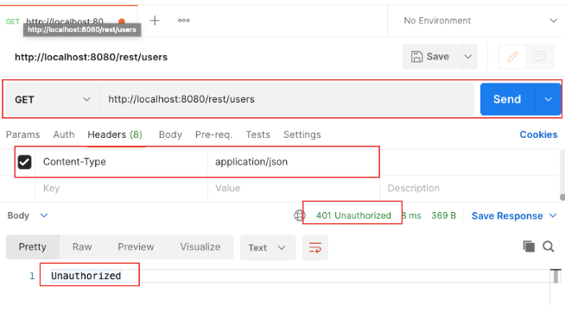
Đăng nhập với tài khoản sena/123456
Kết quả trả về 1 token
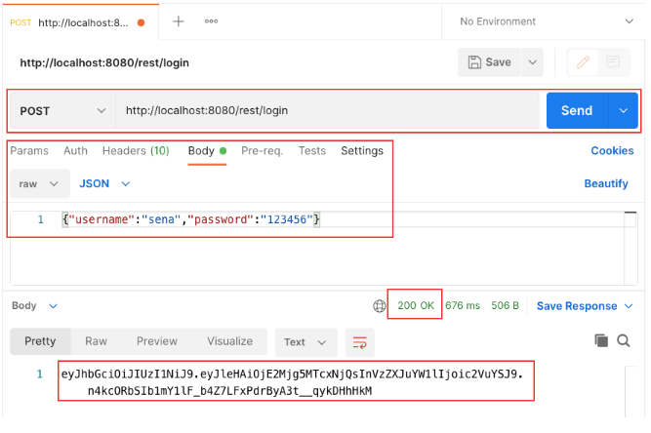
Đính kèm token vừa nhận được vào phần header rồi gửi request lấy thông tin tất cả user:
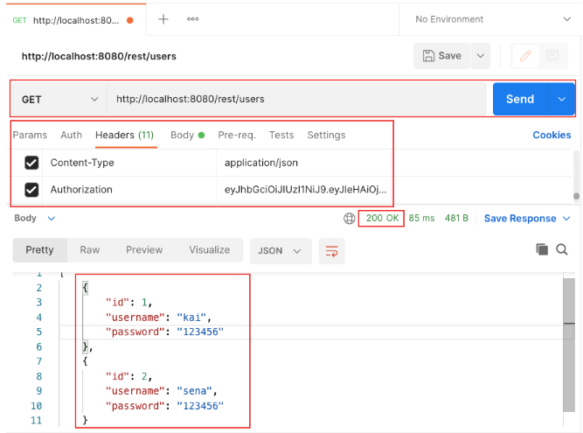
Gửi request tạo mới đối tượng user:
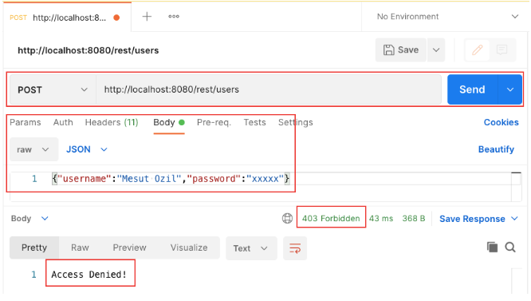
Vì tài khoản sena/123456 chỉ có role USER nên không thể truy cập được url /rest/users với method POST.
Đăng nhập lại với tài khoản kai/123456 và thực hiện thêm mới user:
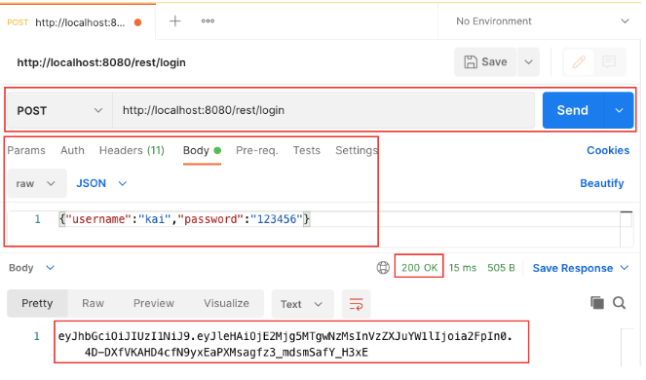
Thực hiện lại thao tác thêm mới User:
Xác định Headers và Body:
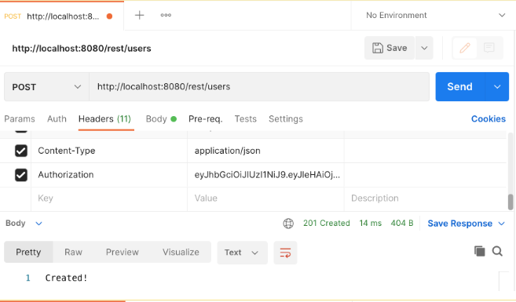
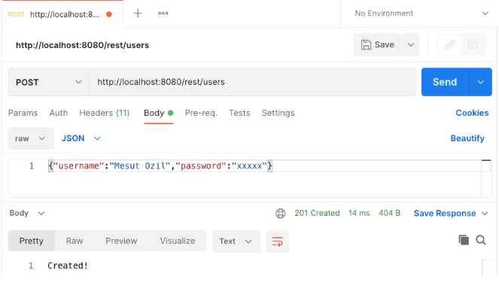
Load lại danh sách User sau khi thêm mới thành công:
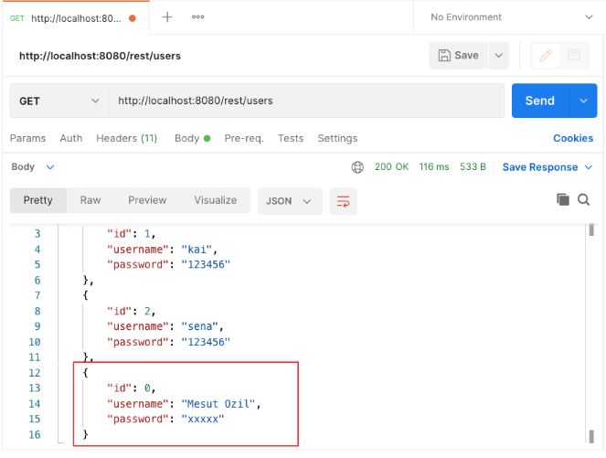
Mã nguồn tham khảo: https://github.com/codegym-vn/springboot-jwt-demo
Hướng dẫn nộp bài:
- Up mã nguồn lên git
- Paste link vào phần nộp bài
Last modified: Saturday, 21 August 2021, 5:17 PM

